**Terms of Reference:**

**SMS Referral Mechanism for the Private Sector**

**Aim:**

To develop an SMS system to more effectively track patients that are referred from the private to the public sector.

Specific Objectives

1. Follow up patients referred from registered private provider (PP) and monitor whether an SMS system was used to alert the corresponding health facility
2. To Follow up patients that never reached the health facility and assess what determining factors contributed to not accessing the public sector
3. To assess the user friendliness and acceptability of the SMS referral system to the private providers, the patient, and the public health facilities

**Rationale**

Reports indicate that more than 70% of malaria patients in Cambodia seek treatment via the private sector. The Public-Private Mix (PPM) project, initiated by the Cambodia National Malaria Programme (CNM) and partners, uses public sector staff to help select and train registered private providers in accordance with National Treatment Guidelines (NTG’s). Among other things, private providers receive training on appropriate diagnosis, treatment and referral procedures. In accordance with NTG’s, private providers in malaria risk zones 2 and3 are permitted to diagnose and treat malaria cases although, children under five, pregnant women, and cases of serious/recurrent malaria should be referred to the public sector while private providers in malaria risk zone 1 should refer all malaria patients to the public sector.

Mechanisms are in place to gather case data from selected private providers, however, it continues to be problematic to track referrals from the private to the public sector. This population is often lost to follow up once they leave the private provider’s facility. The SMS based system being proposed is designed to help more effectively track patients and determine what happens to them after they are referred: do patients continue seeking treatment, where do they go, why don’t they go to the public sector, etc? Without the implementation of a tracking mechanism for these cases, it is impossible to know if these important patients are receiving the treatment they need.

**Program Execution**

Working in conjunction with open source technology tool developer InSTEDD (Innovative Support to Emergencies, Disease and Disasters), CHAI will adapt an SMS based system previously developed by Malaria Consortium (MC) for reporting of malaria resistant cases to work in conjunction with an existing paper based referral system. This system will enable private providers to message information for each patient referred into an online database. The message from private providers will include the referral slip number, patient’s phone number and the reason for the referral. When the patient arrives in the public sector their referral slip information and number will again be sent to the system so that the information can be matched up with the original referral submitted by the private provider. With this information in the system, monitors at CNM will be able to see which patients have been accounted for at public facilities and which have not. A CNM staff member can then follow up and interview the patient to determine what course of treatment, if any, was pursued by the patient after they were referred and work to evaluate why patients are or are not going to the public sector as recommended (see diagram below). In addition, an evaluation of the user-friendliness, challenges and barrier of utilizing this system will be evaluated both at the private provider level and at the health facility level. Recommendation on how to improve the system based on experiences from the pilot study will be included in the M&E report.

Training on the system will be carried out with InSTEDD, local and central level PPM staff and CHAI. InSTEDD provides technical expertise while the PPM team and CHAI have familiarity with the public and private providers that will be utilizing the system. Malaria Consortium will be the overall monitoring and evaluation lead for this pilot. No incentives will be given to providers beyond what is distributed via the PPM mechanism as this pilot will be presented as an additional component to existing PPM work.

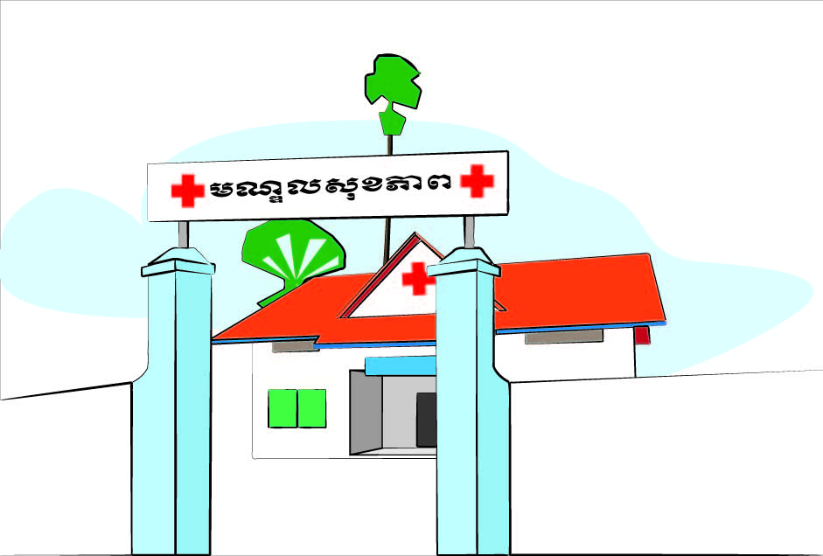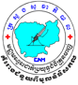

Private provider sends message to system to notify of referred patient

Public provider sends message to system when referral slip is received

Database matches referral slip numbers to determine which patients are going to the public facilities as referred

CNM follows up with patients referred but not reported by the public sector

**Pilot Location**

Due to the emergence of anti-malarial drug resistance, the National Treatment Guidelines require that all Zone 1 private providers refer all malaria patients to the public sector while Zone 2 and Zone 3 private providers only refer the cases most prone to complications, notably pregnant women, children under five, and severe cases. The pilot for this program will be launched in **Sot Nikum operational district (OD)** **in Siem Reap province**. Sot Nikum has private providers located in Zone 2 providing an example of how this mechanism will function in a setting where every malaria case should be referred to the public sector. Sot Nikum is also one of the primary ODs for CNM’s Public-Private Mix program. The private provider network is therefore well developed in this OD, contributing the appropriateness of its selection for participation in this pilot.

**Coordination**

MC will work with CHAI and CNM to design the SMS referral system and provide oversight for the trainings with the private sector. The network of public and private providers that has already been established through the PPM program will be the same utilized to test this system. Trainings will be carried out by a CHAI/CNM team in conjunction with InSTEDD. Malaria Consortium will provide the funding for this pilot through its Global Fund R9 grant as well as lead overall M&E activities. Final evaluation and write up of the pilot will be the responsibility of Malaria Consortium.

**Proposed Indicators**

1. Proportion of registered PP that use the SMS system
2. Proportion of patients referred from the PP using the SMS system
3. Proportion of patients referred from the PP using the SMS system that reached the health facility

**Monitoring and Evaluation (to do)**

**Tentative Timeframe**

|  |  |  |  |  |  |  |
| --- | --- | --- | --- | --- | --- | --- |
|  | Oct (0) | Nov (1) | Dec (2) | Jan (3) | Feb (4) | March (5) |
| Construction of SMS referral system | X |  |  |  |  |  |
| Training of Trainers: PPM staff in Sot Nikum |  | X |  |  |  |  |
| Training of registered Private providers (pharmacies, Clinics etc) |  | X |  |  |  |  |
| Implementation |  |  | X | X | X |  |
| M&E |  |  | X | X | X |  |
| Project dissemination (analysis, write-up, submission) |  |  |  |  |  | X |